UNIT TESTING

Unit testing refers to the practice of testing certain functions and areas – or units – of the code. This gives us the ability to verify that application gui(graphical user interface) work as expected. That is to say that for any function and given a set of inputs, we can determine if the applicatioin is returning the proper values and will gracefully handle failures during the course of execution should invalid input be provided.

The purpose of a unit test is to verify the behavior of a relatively small piece of application, independently from other parts. Unit tests are narrow in scope, and allow us to cover all cases, ensuring that every single part works correctly.

JUnit is a **Regression Testing Framework** used by developers to implement unit testing in Java, and accelerate programming speed and increase the quality of code. JUnit Framework can be easily integrated with either of the following −

* Eclipse
* Ant
* Maven

@Before

**public** **void** setUp() **throws** Exception {

setUpTestData();

}

@After

**public** **void** tearDown() **throws** Exception {

}

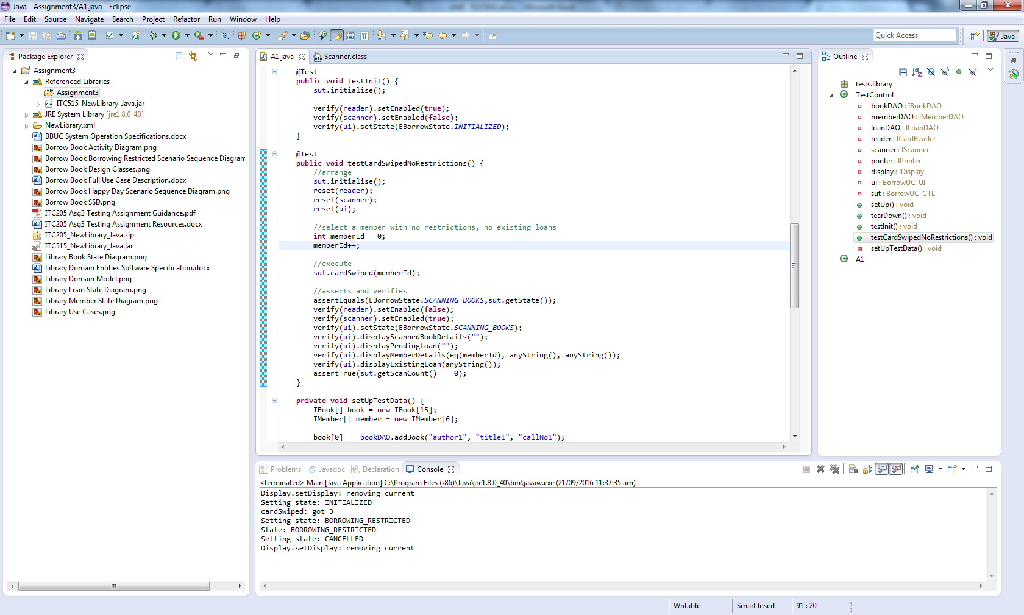

Here I am increasing the member id so they can borrow More books

Before performing unit testing on the application the application is taking only one value which is assigned as 1.When changed to post increment it is taking what ever values given.

